**Functional Document**

|  |  |
| --- | --- |
| **Application** | NGERP - Centra |
| **Service Bundle** | Inventory Management |
| **Service Request** | Stocktake Adjustment |

**Description :**

Stocktake adjustment is used to adjust the stock in the warehouse. If the stock on book is higher or lesser than the quantity in the warehouse user can use stock take adjustment to decrease or increase the stocks accordingly.

**Workflow Process :**

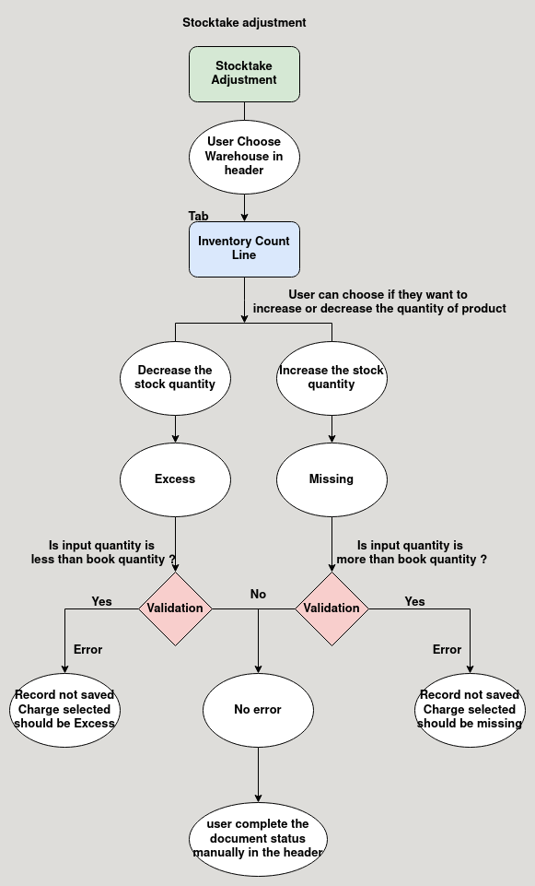

**Business Rules :**

* Stocktake adjustment can be done only in region.
* Document type for stock take adjustment is stocktake adjustment.
* User choose warehouse in the stocktake adjustment header.
* User choose locator in inventory line and product they want to increase or decrease.
* Application will automatically load the total quantity in the inventory.
* User can increase or decrease the quantity using charge account excess or missing.
* The stocks can be increased or decreased only in suspense warehouse.
* User cannot give lesser quantity than book quantity in excess type.
* User cannot give highrer quantity than book quantity in missing type.